This songbook was compilated by Aleksandra W.
Hugs and kisses are kindly accepted, while complains

should be sent to dev.

BEST ŁÓDŹ proudly presents this

Song Book

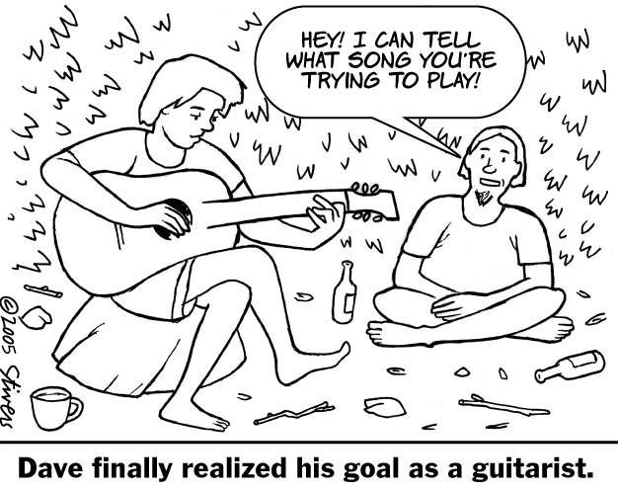

Przybieżeli do Betlejem
Przybieżeli do Betlejem pasterze
Grając skoczno Dzieciąteczku na lirze.

Chwała na wysokości,
chwała na wysokości,
a pokój na ziemi.

Oddawali swe ukłony w pokorze
Tobie z serca ochotnego, o Boże!

Anioł Pański sam ogłosił te dziwy
Których oni nie słyszeli jak żywi.

Dziwili się na powietrzu muzyce,
I myśleli: “Co to będzie za Dziecię?”

Któremu się wół i osioł kłaniają,
Trzej królowie podarunki oddają?

I Anieli gromadami pilnują,
Panna Przeczysta z Józefem piastują?

Poznali Go Mesjaszem być prawym,
Narodzonym dzisiaj Panem łaskawym.

My Go także Bogiem, Zbawcą już znamy,
I z całego serca wszyscy kochamy.

29.

Lulajże, Jezuniu
Lulajże, Jezuniu, moja perełko,
lulaj, ulubione me pieścidełko.
Lulajże, Jezuniu, lulajże, lulaj,
a Ty Go, Matulu, w płaczu utulaj.
Zamknijże znużone płaczem powieczki,
utulże zemdlone łkaniem wardzeczki.
Lulajże, piękniuchny mój aniołeczku,
lulajże, maluchny świata kwiateczku.
Lulajże różyczko najozdobniejsza,
lulajże, lilijko najprzyjemniejsza.
Lulajże, przyjemna oczom gwiazdeczko,
lulaj, najśliczniejsze świata słoneczko.
Matuniu kochana, już odchodzimy,
małemu Dzieciątku przyśpiewujemy.
Cyt cyt cyt, już zaśnie małe Dzieciątko,
patrz jeno, jak to śpi niby kurczątko.
Cyt cyt cyt, wszyscy się spać zabierajcie,
mojego Dzieciątka nie przebudzajcie.

28.

Song Book



I would like to thank Mark Stivers who has
kindly given permission of copyright materials.
You can see more of his works in the following
publications: Harper’s, San Francisco Bay Guardian,
The American Enterprise and many others.

A crowded room - Friends with tired eyes
I'm hiding from you, and your soul of ice
My God I thought you were someone to rely on
Me - I guess I was a shoulder to cry on

Face on her lover
With a fire in her heart
A girl undercover.....she tore me apart Ohhh
Now I've found a real love
You'll never fool me again

Last Christmas I gave you my heart
But the very next day you took it away
This year, to save me from tears
I'll give it to someone special

Last Christmas I gave you my heart
But the very next day you took it away
This year, to save me from tears
I'll give it to someone special

Last Christmas I gave you my heart
But the very next day you took it away
This year, to save me from tears
I'll give it to someone special

(Fade)
Last Christmas I gave you my heart
But the very next day you took it away
This year, to save me from tears
I'll give it to someone special

27.
Last Christmas
Last Christmas
I gave you my heart
But the very next day you took it away
This year, to save me from tears
I'll give it to someone special

Last Christmas I gave you my heart
But the very next day you took it away
This year, to save me from tears
I'll give it to someone special

Once bitten and twice shy
I keep my distance
But just don't catch my eye
Tell me baby
Do you recognise me?
Well its been a year
It doesn't surprise me

I wrapped it up and sent it
With a note saying "I love you" - I meant it
Now I know what a fool I've been
But if you kissed me now
I know you'll fool me again

Last Christmas I gave you my heart
But the very next day you took it away
This year, to save me from tears
I'll give it to someone special

Last Christmas I gave you my heart
But the very next day you took it away
This year, to save me from tears
I'll give it to someone special
26.

INDEX

Yellow Submarine – John Lennon / Paul McCartney .................5
Lemon Tree - Fool's Garden.........................................................6
You are beautiful – James Blunt...................................................8
Losing My Religion -R.E.M. .......................................................9
Simply The Best - Tina Turner...................................................10
Kołysanka dla nieznajomej -Perfect...........................................11
E greu... ......................................................................................12
Ma dusei sa trec la olt.................................................................13

Hotel Cismigiu............................................................................14
Hotel California..........................................................................15

BIRTHDAY SONGS
Happy Birthday...........................................................................17
Bonne Fete A Toi........................................................................17
Sto lat..........................................................................................17
La multi ani.................................................................................17
Il est se nôtres.............................................................................18

CAROLS AND CHRISTMAS SONGS
Silent Night.................................................................................19
Cicha noc....................................................................................20
Noapte de vis..............................................................................21
Sainte Nuit..................................................................................22
Jingle Bells..................................................................................23
Rudolph The Red Nosed Reindeer ............................................24
White Christmas.........................................................................25
Last Christmas............................................................................26
Lulajże, Jezuniu..........................................................................28
Przybieżeli do Betlejem..............................................................29

White Christmas

I'm dreaming of a white Christmas
Just like the ones I used to know
Where the treetops glisten,
and children listen
To hear sleigh bells in the snow
I'm dreaming of a white Christmas
With every Christmas card I write
May your days be merry and bright
And may all your Christmases be white
I'm dreaming of a white Christmas
With every Christmas card I write
May your days be merry and bright
And may all your Christmases be white

25.

Rudolph The Red Nosed Reindeer

You know Dasher, and Dancer, and
Prancer, and Vixen,
Comet, and Cupid, and
Donner and Blitzen
But do you recall
The most famous reindeer of all
Rudolph, the red-nosed reindeer
had a very shiny nose
and if you ever saw it
you would even say it glows.
All of the other reindeer
used to laugh and call him names
They never let poor Rudolph
play in any reindeer games.
Then one foggy Christmas eve
Santa came to say:
"Rudolph with your nose so bright,
won't you guide my sleigh tonight?"
Then all the reindeer loved him
as they shouted out with glee,
Rudolph the red-nosed reindeer,
you'll go down in history!

24.

Yellow Submarine

In the town where I was born
Lived a man who sailed to sea
And he told us of his life
In the land of submarines
So we sailed up to the sun
Till we found the sea of green
And we lived beneath the waves
In our yellow submarine

We all live in our yellow submarine,
Yellow submarine, yellow submarine
We all live in our yellow submarine,
Yellow submarine, yellow submarine
And our friends are all on board
Many more of them live next door
And the band begins to play
We all live in our yellow submarine,
Yellow submarine, yellow submarine
We all live in our yellow submarine,
Yellow submarine, yellow submarine
As we live a life of ease
Everyone of us has all we need
Sky of blue and sea of green
In our yellow submarine.
We all live in our yellow submarine,
Yellow submarine, yellow submarine
We all live in our yellow submarine,
Yellow submarine, yellow submarine
5.

Fool's Garden - Lemon Tree

I'm sitting here in a boring room
It's just another
Rainy Sunday afternoon
I'm wasting my time
I got nothing to do
I'm hanging around
I'm waiting for you
But nothing ever happens - and I wonder
I'm driving around in my car
I'm driving too fast
I'm driving too far
I'd like to change my point of view
I feel so lonely
I'm waiting for you
But nothing ever happens - and I wonder
I wonder how I wonder
Why yesterday you told me
About the blue blue sky
And all that I can see is just
A yellow lemon tree
I'm turning my head up and down
I'm turning turning turning turning
Turning around
And all that I can see is just
Another lemon tree
I'm sitting here, I miss the power
I'd like to go out taking a shower
But there's heavy cloud inside my head
I feel so tired, put myself into bed
Where nothing ever happens - and I wonder
Isolation - is not good for me
Isolation - I don't want
6.

Jingle Bells

Dashing through the snow
In a one horse open sleigh
O'er the fields we go
Laughing all the way
Bells on bob tails ring
Making spirits bright
What fun it is to laugh and sing
A sleighing song tonight
Oh, jingle bells, jingle bells
Jingle all the way
Oh, what fun it is to ride
In a one horse open sleigh
Jingle bells, jingle bells
Jingle all the way
Oh, what fun it is to ride
In a one horse open sleigh
A day or two ago
I thought I'd take a ride
And soon Miss Fanny Bright
Was seated by my side
The horse was lean and lank
Misfortune seemed his lot
We got into a drifted bank
And then we got upsot
Oh, jingle bells, jingle bells
Jingle all the way
Oh, what fun it is to ride
In a one horse open sleigh
Jingle bells, jingle bells
Jingle all the way
Oh, what fun it is to ride
In a one horse open sleigh yeah
Jingle bells, jingle bells
Jingle all the way
Oh, what fun it is to ride
In a one horse open sleigh
Jingle bells, jingle bells
Jingle all the way
Oh, what fun it is to ride
In a one horse open sleigh

23.
Sainte Nuit
Ô nuit de paix, Sainte nuit
Dans le ciel L'astre luit
Dans les champs tout repose en paix
Mais soudain dans l'air pur et frais
Le brillant coeur des anges
Aux bergers apparaît
Ô nuit de foi, Sainte nuit
Les bergers sont instruits
Confiants dans la voix des cieux
Ils s'en vont adorer leur Dieu
Et Jésus, en échange
Leur sourit radieux
Ô nuit d'amour, Sainte nuit
Dans l'étable, aucun bruit
Sur la paille, est couché l'enfant
Que la Vierge endort en chantant
Il repose en ses langes
Son Jésus ravissant
Ô nuit d'espoir, Sainte nuit
L'espérance a reluit
Le Sauveur de la terre est né
C'est à nous que Dieu l'a donné
Célébrons ses louanges
Gloire au Verbe incarné
22.

To sit on a lemon tree
I'm stepping around
In a desert of joy, baby
Anyhow I'll get
Another toy and
Everything will happen
And you'll wonder
I wonder how I wonder
Why yesterday you told me
About the blue blue sky
And all that I can see is just
A yellow lemon tree
I'm turning my head up and down
I'm turning turning turning turning
Turning around
And all that I can see is just
Another lemon tree

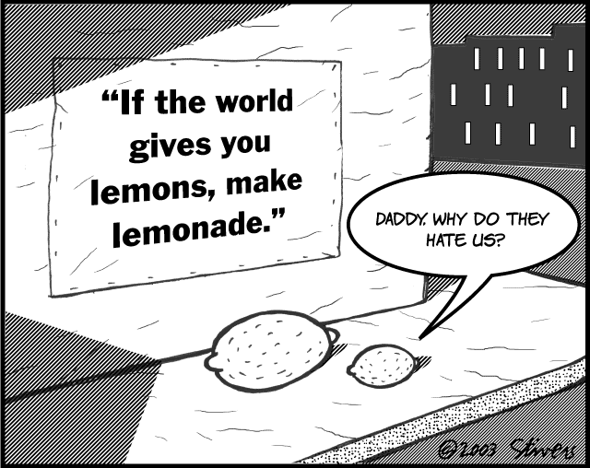

7.
You are beautiful – James Blunt

My life is brilliant, My love is pure
I saw an angel, of that I’m sure
She smiled at me on the subway
She was with another man
But I won’t lose no sleep on that ‘Cause I’ve got a plan

You’re beautiful, You’re beautiful,
You’re beautiful, It’s true
I saw your face In a crowded place
And I don’t know what to do
‘Cause I’ll never be with you

Yes, she caught my eye As we walked on by
She could see from my face that I was
Fucking high
And I don’t think that I’ll see her again
But we shared a moment that will last to the end

La –la- la – la - La –la- la – la - La –la- la – la

You’re beautiful, You’re beautiful,
You’re beautiful, It’s true
There must be an angel
With a smile on her face
When she was thought up that I should be with you
I will never be with you
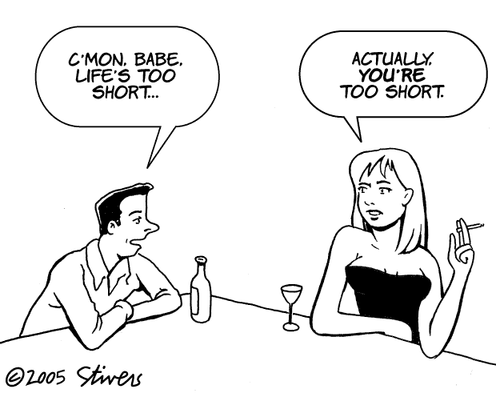

8.

Noapte de vis

Noapte de vis, timp preasfânt,
Toate dorm pe pământ;
Doar două inimi veghează,
Pruncul dulce visează
Într-un leagăn de cânt.
Noapte de vis, timp preasfânt,
Dumnezeu râde blând;
Pieptu-i varsă iubire,
Lumii dă mântuire
Pace-n ea aducând.
Noapte de vis, timp preasfânt,
Păstoraşi vin cântând;
Îngerii cântă Aleluia,
Nouă ne vestesc bucuria,
Domnul e pe pământ.

21.

Cicha noc

Cicha noc, święta noc
Pokój niesie ludziom wszem
A u żłóbka Matka święta
Czuwa sama uśmiechnięta
Nad dzieciątka snem
Nad dzieciątka snem
Cicha noc, święta noc
Pastuszkowie od swych trzód
Biegną wielce zadziwieni
Za anielskich głosem pieśni
Gdzie się spełnił cud
Gdzie się spełnił cud
Cicha noc, święta noc
Narodzony Boży Syn
Pan wielkiego majestatu
Niesie dziś całemu światu
Odkupienie win
Odkupienie win
Cicha noc, święta noc
Jaki w tobie dzisiaj cud
W Betlejem dziecina święta
Wznosi w górę swe rączęta
Błogosławi lud

20.
R.E.M. - Losing My Religion

Life is bigger
It's bigger than you
And you are not me
The lengths that I will go to
The distance in your eyes
Oh no I've said too much
I set it up
That's me in the corner
That's me in the spotlight
Losing my religion
Trying to keep up with you
And I don't know if I can do it
Oh no I've said too much
I haven't said enough
I thought that I heard you laughing
I thought that I heard you sing
I think I thought I saw you try
Every whisper
Of every waking hour I'm
Choosing my confessions
Trying to keep an eye on you
Like a hurt lost and blinded fool
Oh no I've said too much
I set it up
Consider this
The hint of the century
Consider this
The slip that brought me
To my knees failed
What if all these fantasies
Come flailing around
Now I've said too much
I thought that I heard you laughing
I thought that I heard you sing
I think I thought I saw you try
But that was just a dream
That was just a dream
9.

Tina Turner - Simply The Best

I call you when I need you, my heart's on fire
You come to me, come to me wild and wild
When you come to me
Give me everything I need
Give me a lifetime promises and a world of dreams
Speak a language of love like you know what it
means
And it can't be wrong
Take my heart and make it strong baby

You're simply the best, better than all the rest
Better than anyone, anyone I've ever met
I'm stuck on your heart, and hang on every word
you say
Tear us apart, baby I would rather be dead
In your heart I see the star of every night and
every day
In your eyes I get lost, I get washed away
Just as long as I'm here in your arms
I could be in no better place

Each time you leave me I start losing control
You're walking away with my heart and my soul
I can feel you even when I'm alone
Oh baby, don't let go
You’re the best

10.

CAROLS AND CHRISTMAS SONGS

Silent Night

Silent night! Holy night!
All is calm, all is bright
round yon virgin mother and child,
Holy infant so tender and mild,
sleep in Heavenly peace!
sleep in Heavenly peace!
Silent night! Holy night!
Shepherds quake at the sight;
glories stream from Heaven afar,
Heavenly hosts sing Alleluia,
Christ, the Saviour, is born!
Christ, the Saviour, is born!
Silent night! Holy night!
Son of God, Love's pure light
radiant beams from Thy Holy face,
with the dawn of redeeming grace,
Jesus, Lord at Thy birth,
Jesus, Lord at Thy birth.

19.
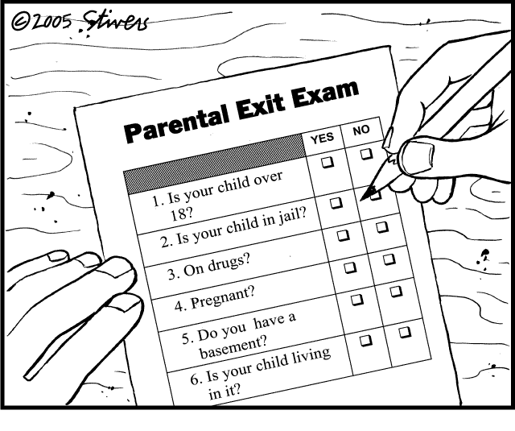

Il est se nôtres

Ami [name], ami [name], lève ton verre
Et surtout, ne le renverse pas!
Ami [name], ami [name], lève ton verre
Et surtout, ne le renverse pas!

Et porte-le
Au frontibus
Au nez-tibus
Au mentibus
Au plexibus
Au ventribus
Au sexibus

Et glou et glou et glou...
Il est se nôtres !
Il a bu son verre comme les autres !
C’est un ivrogne,
Ça se voit rien qu’à sa trogne !

18.
Kołysanka dla nieznajomej

Gdy nie bawi cię już
Świat zabawek mechanicznych
Kiedy dręczy cię ból
Niefizyczny
Zamiast słuchać bzdur
Głupich telefonicznych wróżek
zza siedmiu mórz
Spytaj siebie czego pragniesz
Dlaczego kłamiesz że miałaś wszystko
Gdy udając że śpisz
W głowie tropisz bajki z gazet
Swoje miejsce znajdź
I nie pytaj czy taki układ ma jakiś sens
Słuchaj co twe ciało mówi
W miłosnej studni już nie utoniesz
Kochaj mnie
Kochaj mnie
Kochaj mnie nieprzytomnie
Jak zapalniczka płomień
Jak słucha studnia wodę
Kochaj mnie
Kochaj mnie
Kochaj mnie nieprzytomnie
Jak księżyc w oknie śmiej się i płacz
Na linie nad przepaścią tańcz
Aż w jedną krótką chwilę
Pojmiesz po co żyjesz
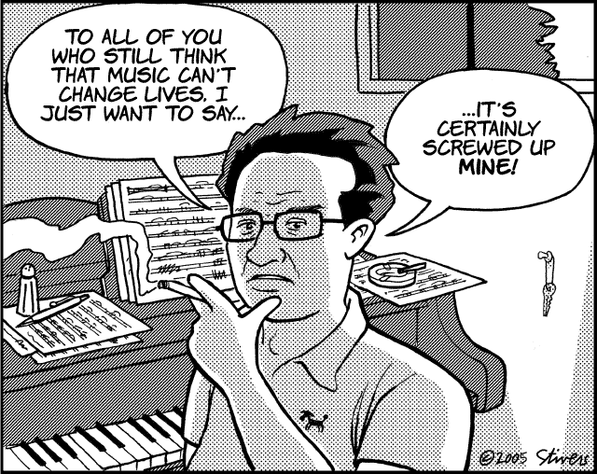
Kiedy nie chcesz już śnić
Cudzych marzeń
Boso do mnie przyjdź
I od progu bezwstydnie
powiedz mi czego chcesz
Słuchaj jak dwa serca biją
Co ludzie myślą - to nieistotne
Kochaj mnie
Kochaj mnie
Kochaj mnie nieprzytomnie
Jak zapalniczka płomień
Jak sucha studnia wodę
Kochaj mnie namiętnie tak
Jakby świat się skończyć miał

11.
E greu...
E greu , e greu, e foarte greu
E greu , e greu, e foarte greu
Sa ai femeie in Hasdeu
Te scoala noaptea pe la patru:
-Gicule , mai tine patu?
-Aham!
-No, da-i!
E greu , e greu, e foarte greu
Sa ai gagica in Hasdeu
Te scoala noaptea pe la cinci:
-Gicule , ne vad parinti?
-Aham!
-No, da-i!

Sa ai femeie in Hasdeu
Te scoala noaptea pe la unu:
-Gicule , mai dai cu tunu?
-Aham!
-No, da-i!
E greu , e greu, e foarte greu
Sa ai femeie in Hasdeu
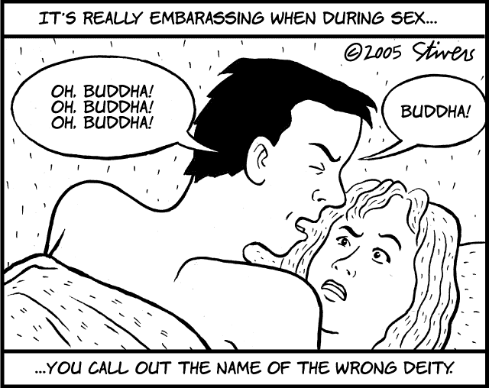
Te scoala noaptea pe la doua:
-Gicule , mai ploua?
-Aham!
-No, da-i!
E greu , e greu, e foarte greu
Sa ai femeie in Hasdeu
Te scoala noaptea pe la trei:
-Gicule , mai vrei?
-Aham!
-No, da-i!

12.

BIRTHDAY SONGS

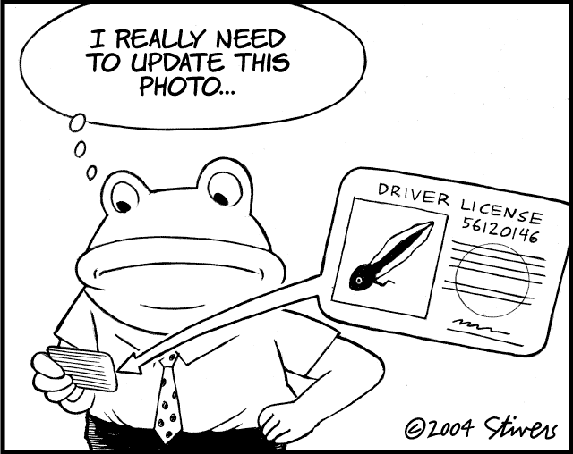
Bonne Fete A Toi
Bonne Fete A Toi
Bonne Fete A Toi
Bonne Fete A [name]
Bonne Fete A Toi

Happy Birthday
Happy Birthday to you
Happy Birthday to you
Happy birthday, dear [name]
Happy Birthday to you!

La multi ani

Multi ani traiasca, multi ani traiasca,
la multi ani!
Cine sa traiasca? Cine sa traiasca?
La multi ani!
[name] sa traiasca,
[name] sa traiasca, la multi ani!
La multi ani cu sanatate!
Sa iti dea Domnul tot ce doresti,
Zile senine si fericite,
La multi ani sa traiesti!

Sto lat
Sto lat, Sto lat
niech żyje , żyje nam
Sto lat, Sto lat
niech żyje , żyje nam
Jeszcze raz, jeszcze raz,
niech żyje, żyje nam
Niech żyje nam!

17.
Some dance to forget
So I called up the Captain
Please bring me my wine
He said
We haven't had that spirit here since 1969
And still those voices are calling from far away
Wake you up in the middle of the night
Just to hear them say
Welcome to the Hotel California
Such a lovely Place
Such a lovely Place (background)
Such a lovely face
They're livin' it up at the Hotel California
What a nice surprise
What a nice surprise (background)
Bring your alibies
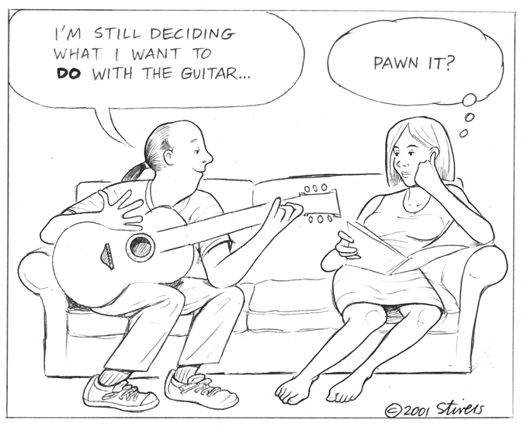
Mirrors on the ceiling
Pink champagne on ice
And she said
We are all just prisoners here
Of our own device
And in the master's chambers
They gathered for the feast
They stab it with their steely knives
But they just can't kill the beast
Last thing I remember
I was running for the door
I had to find the passage back to the place I was before
Relax said the nightman
We are programed to recieve
You can check out any time you like
But you can never leave

16.
Ma dusei sa trec la olt

Ma dusei, da ma dusei sa trec la Olt,
Ma dusei, da ma dusei sa trec la Olt,
Cu a mea, cu a mea, cu a mea mandra cu tot, la, la, la, la, la, la, la...
Cu a mea, cu a mea, cu a mea mandra cu tot, la, la, la, la, la, la, la...
Dar podariul, dar podariul imi cere-un zlot,
Dar podariul, dar podariul imi cere-un zlot,
Si pe-a mea si pe-a mea si pe-a mea mandra de tot, la, la, la, la, la, la, la...
Si pe-a mea si pe-a mea si pe-a mea mandra de tot, la, la, la, la, la, la, la...
Dar decat, dar da decat sa-i dau un zlot,
Dar decat, dar da decat sa-i dau un zlot,
Mai bine, mai bine, mai bine trec Oltu'n inot, la, la, la, la, la, la, la...
Mai bine, mai bine, mai bine trec Oltu'n inot, la, la, la, la, la, la, la...
Pe unde o fi, pe unde o fi Oltul mai mare,
Pe unde o fi, pe unde o fi Oltul mai mare,
M-o trece, m-o trece, m-o trece mandra-n spinare, la, la, la, la, la, la, la...
M-o trece, m-o trece, m-o trece mandra-n spinare, la, la, la, la, la, la, la...
Pe unde o fi, pe unde o fi Oltul mai mic,
Pe unde o fi, pe unde o fi Oltul mai mic,
Il trec eu, il trec eu, il trec eu ca sunt voinic, la, la, la, la, la, la, la...
Il trec eu, il trec eu, il trec eu ca sunt voinic, la, la, la, la, la, la, la...
Strofa pentru varianta studenteasca:
Pe unde o fi, pe unde o fi Oltul mai lent,
Pe unde o fi, pe unde o fi Oltul mai lent,
Il trec eu, il trec eu, il trec eu ca sunt student, la, la, la, la, la, la, la...
Il trec eu, il trec eu, ïl trec eu ca sunt student, la, la, la, la, la, la, la...

13.

Hotel Cismigiu

E pustiu, e-ntuneric... si mi-e frica de mor
Locuiesc intr-o hruba, la cap de coridor
Sunt racit si mi-e foame si nu am chior de ban
Fericirea-i la bursa dar nici p-aia n-o am
Nu am bani nici de paine, n-am platit nici chiria
Nu dau pe ochi frumosi vodca la "Omenia"
Misuna presa-n strada si e plin de tigani
E gunoi si e curve, da' si alea vrea bani.
Welcome to the Hotel Cismigiu
Such a lovely place
Such a lovely place
E ca un sicriu.
Sa te fut in Hotel Cismigiu
Imi e frica si tremur
Imi e frica si tremur
De un nou cutremur...
Dar ma bucur teribil si zambesc ne-ncetat
Cu un rictus de hiena care-asa a inghetat
Mi-ai distrus tineretea, sanatatea la fel
Fir-ai al dracului de buncar care-ti zice hotel.
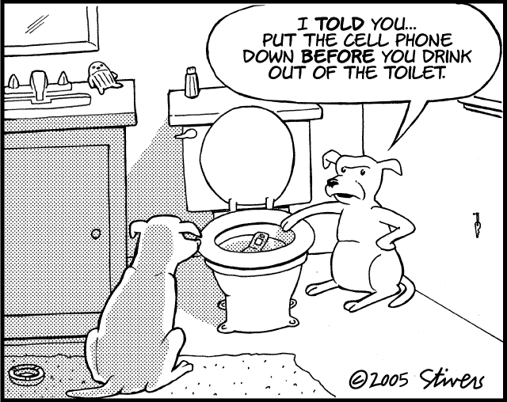
Ne cacam pe-ntuneric
Stam cu cracii-n pisat
Aicea nu-i de mine
Eu sunt un delicat
Vreau o buda normala
Si un dus cat de cat
Americanii-s de vina
Futu-i in gura sa-i fut.

14.
Hotel California

On a dark desert highway
Cool wind in my hair
Warm smell of colitas
Rising up through the air
Up ahead in the distance
I saw a shimmering light
My head grew heavy, and my sight grew dim
I had to stop for the night
There she stood in the doorway
I heard the mission bell
And I was thinking to myself
This could be Heaven or this could be Hell
Then she lit up a candle
And she showed me the way
There were voices down the corridor
I thought I heard them say
Welcome to the Hotel California
Such a lovely place
Such a lovely place (background)
Such a lovely face
Plenty of room at the Hotel California
Any time of year
Any time of year (background)
You can find it here
You can find it here
Her mind is Tiffany twisted
She's got the Mercedes bends
She's got a lot of pretty, pretty boys
That she calls friends
How they dance in the courtyard
Sweet summer sweat
Some dance to remember
15.

